**Citation searching – Why and how**

**Why?**

**Too few references**

If you are having problems locating relevant research papers through searching databases etc, one way to find more papers is to look at the references at the end of the papers you have. – they are likely to be on the same or a closely related topic. This takes you back in time, identifying older papers.

To go forward in time you need to be able to find out what more recent papers have cited the ones you already have. The **Web of Science** **Core Collection** database allows you to do this for journal articles.

**You have identified the key paper(s) in your research topic**

Similarly you may have identified the journal article(s) which started off the research in your topic. **Web of Science Core Collection** allows you to identify more recent papers which have cited the original articles as part of their reference list.

**How**

Let’s use an example. I am interested in identifying papers which have cited the following journal article:

“Use of electrophoretic deposition in the processing of fibre reinforced ceramic and glass matrix composites: a review”

Authors: Boccaccini AR; Kaya, C; Chawla KK

COMPOSITES PART A-APPLIED SCIENCE AND MANUFACTURING Vol: 32 Iss: 8, Pages: 997-1006 Pub year: 2001

1. **Go to the Web of Science Core Collection database:**

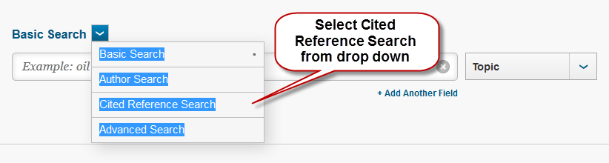

1. **Carry out citation search:**

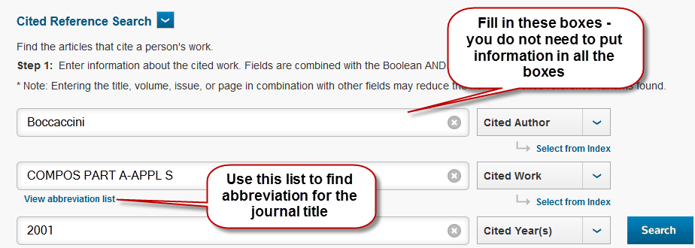

Locate journal abbreviation in list:

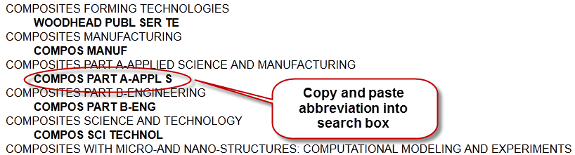

1. **Select references**

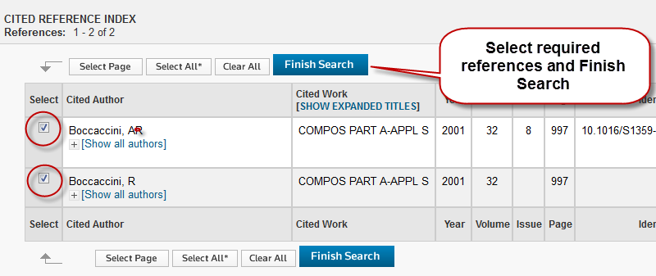

This produces a list of results of papers with the Boccaccini article in their reference list